**TEST CASES**

1. Fetching Bank List –

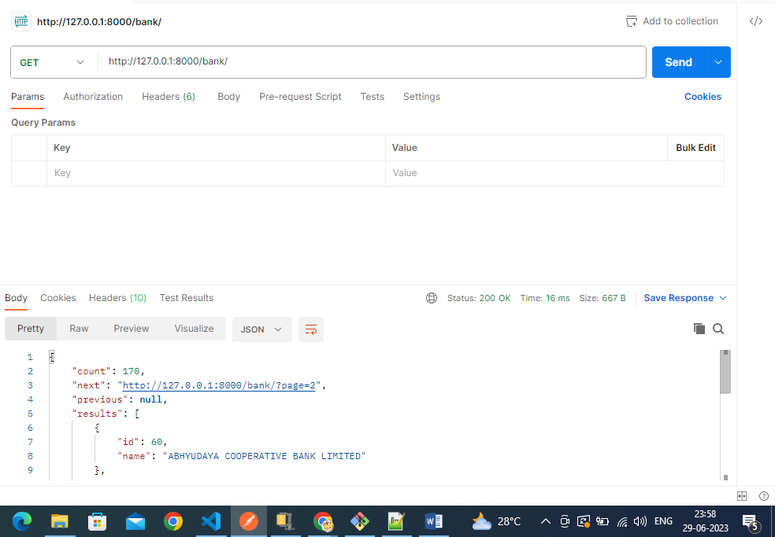

2. Fetching Branch List:

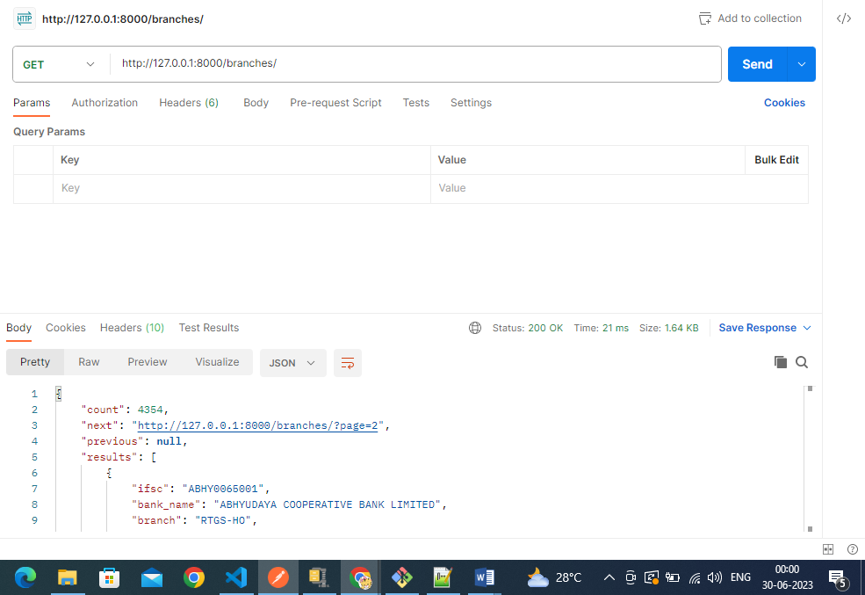

3. Bank and branch details for : /?branch=DARUKHANA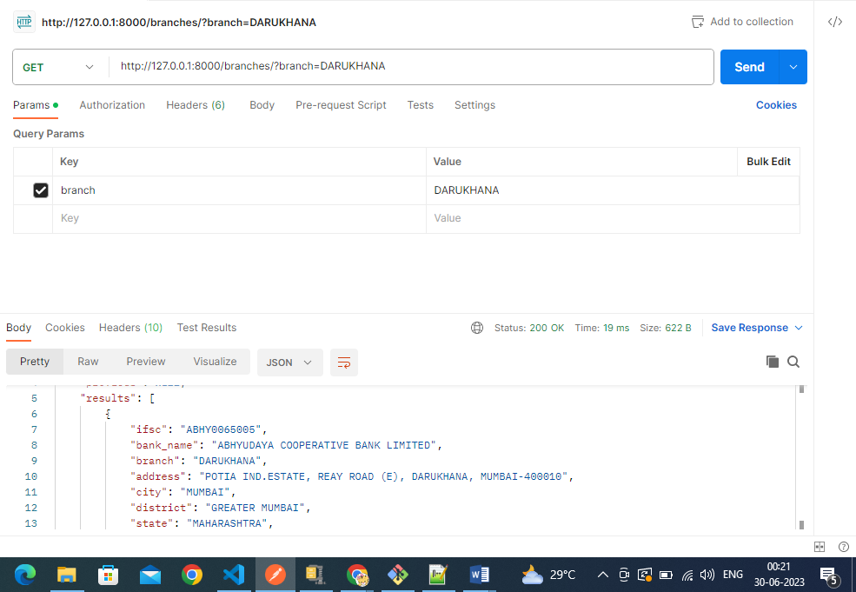

4. Bank and branch details for : ***/?branch=NEW PANVEL***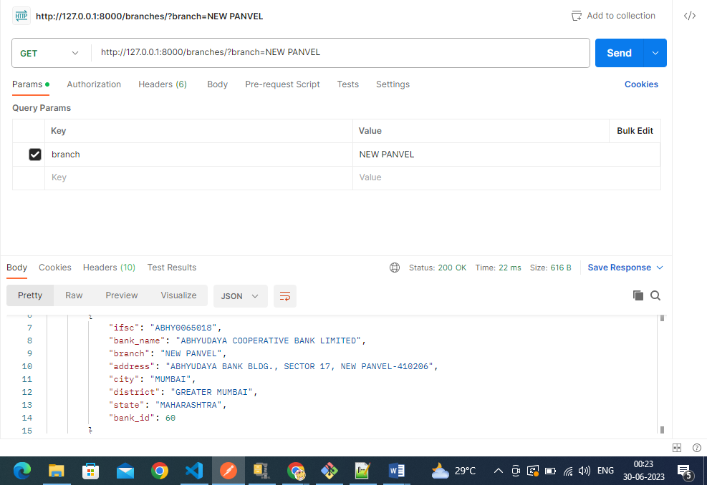

5. Bank and branch details if branch is given in lowercase:***/?branch=borivali***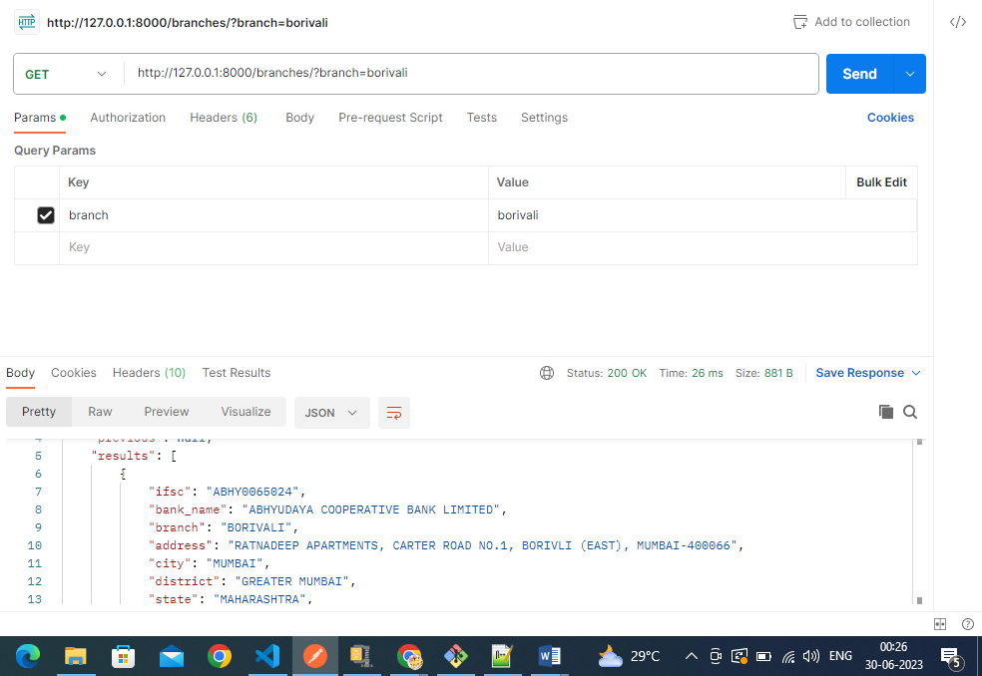

6. Bank List and branch details if branch name is wrong: ***/?branch=xyz***